VIT BHOPAL UNIVERSITY
Python Password Generator and Strength Checker
Mini project report
Submitted by: LAKSHITA SAINI
Registration no.: 25BAI10514
Course: B.Tech CSE (AI-ML)
Semester: 1
Faculty: Ms. MK Jayanthi

Introduction
In the digital age, securing online accounts and sensitive information is crucial. One of the primary methods of protection is through strong and complex passwords. However, users often create weak or easily guessable passwords due to the difficulty of memorizing complex strings. This project aims to provide an easy-to-use, secure password generator that produces customizable, strong passwords and evaluates their strength, thereby improving password security awareness and practices.

Problem Statement
Many users rely on weak or repetitive passwords, making them vulnerable to cyber attacks such as brute force or dictionary attacks. Existing password creation tools may lack customization or easy assessment of password strength. This project focuses on generating strong passwords with user-defined criteria and providing immediate feedback on password robustness to encourage better security habits.

Objectives
- To develop a secure and customizable password generator that produces strong passwords based on user preferences.
- To enable users to specify password length and choose character types (uppercase, digits, special characters).
- To implement cryptographically secure randomization using Python’s secrets module for password generation.
- To evaluate and display the strength of generated passwords, helping users understand password robustness.
- To provide a simple and interactive command-line interface for ease of use.
- To promote better password security practices by encouraging the use of strong, diverse passwords.

Existing Systems
There are many password generators available, such as online tools and password manager apps. Most focus on basic password creation without detailed strength evaluation. Some built-in OS tools provide generation but lack customization. This project offers a simple, secure, and customizable password generator with strength assessment through a command-line interface, aiming for ease of use and educational value.

Functional Requirements
- The system shall generate random passwords based on user input.
- Users can specify password length.
- Users can choose to include uppercase letters, digits, and special characters.
- The system shall evaluate and display password strength as Weak, Moderate, or Strong.
- The system shall provide a simple, interactive command-line interface.

Non-functional Requirements
- Security: Passwords must be generated using cryptographically secure methods.
- Usability: The interface shall be user-friendly and intuitive.
- Reliability: The system must consistently generate passwords without errors.
- Performance: Password generation and strength evaluation should be instantaneous.

System Architecture
The system consists of three main components:
- User Input Module: Captures password preferences.
- Password Generation Module: Uses Python’s secrets module to create passwords based on criteria.
- Strength Evaluation Module: Analyzes password length and character variety to assess strength.
Data flows from user input to password generation and then to the evaluation module, with results displayed back to the user.

UML DIAGRAMS
Use case diagram
User

Display password and strength
Evaluate password strength
Generate password
Input password info
Workflow Diagram
Start

End
Password and strength shown
Password is generated
Password is generated
User enters length and options

Sequence Diagram
User
User inputs password data
System generates password
System evaluates password strength user
System
System
System
Proposed Systems
This project proposes a secure and customizable password generator that allows users to specify password length and character types. It uses Python’s secrets module for cryptographically secure randomization. The system evaluates and displays password strength instantly, helping users create strong passwords easily through a simple command-line interface focused on usability and security.

Software Requirements
- Python 3.x installed on the system
- A code editor or IDE (e.g., VS Code, PyCharm, or any text editor)
- Operating System: Windows, macOS, or Linux capable of running Python scripts
- Command-line interface or terminal
Hardware Requirements
- Any standard personal computer or laptop with minimum 2GB RAM
- Processor: Intel i3 or equivalent and above
- At least 100MB free disk space for project files and Python installation

SDLC Model Used
The project uses the Incremental Model of Software Development Life Cycle (SDLC). Development is divided into smaller modules like password generation, strength evaluation, and user interface, with each module developed and tested incrementally. This approach allows iterative improvement and easier debugging. It supports clear milestone-based progress and accommodates requirement refinements during development.

System Design and Architecture
The system is designed with a modular architecture consisting of three main components:
- User Input Module: Captures user preferences such as password length and character options.
- Password Generation Module: Utilizes Python’s secrets module to generate secure, random passwords based on input criteria.
- Password Strength Evaluation Module: Analyzes the generated password for length and character diversity to determine strength.
The components interact sequentially, ensuring clear data flow from user input to password generation and strength assessment, with results displayed back to the user through a command-line interface. This modular design promotes maintainability, scalability, and ease of testing.

Algorithm
- Start the program.
- Ask the user how long they want the password to be.
- Ask the user if they want to include uppercase letters, numbers, and special characters.
- Create a list of characters based on what the user selected.
- Randomly pick characters from the list until the password reaches the chosen length.
- Check the password to see how strong it is (looking at length and types of characters).
- Show the generated password and its strength to the user.
- End the program.

Implementation
The password generator is implemented in Python using the string and secrets modules to ensure secure and customizable password creation. The program starts by taking user inputs for password length and character preferences (uppercase letters, digits, special characters). Based on these preferences, it constructs a character set from which characters are randomly and securely selected using secrets.choice().
The use of secrets module ensures cryptographically strong randomness, making the generated passwords more secure compared to basic randomization methods. After generating the password, a strength evaluation is performed checking for length and diversity of character types. The program then displays the generated password along with its strength rating (Weak, Moderate, Strong) in the command-line interface.
This approach combines security, user customization, and simple interaction, making it suited for users seeking strong, reliable passwords without complexity.

Screenshots of how program runs.

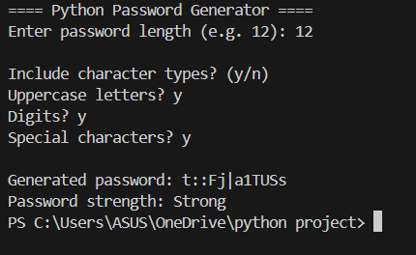

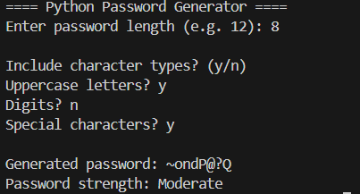
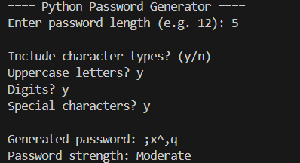

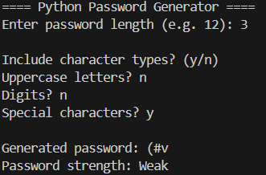

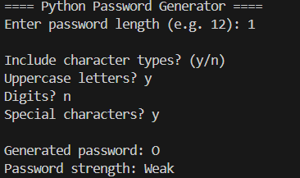

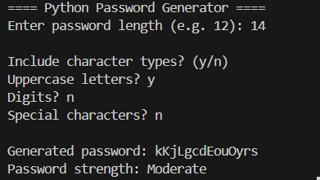

Testing
The password generator program was tested through multiple test cases to ensure correct functionality and secure password generation.
- Input Validation: Tested with various password lengths, including minimum and large values, to check if the program handles inputs gracefully.
- Character Inclusion: Verified that passwords include uppercase letters, digits, and special characters based on user selections.
- Password Length: Confirmed generated passwords match the requested length exactly.
- Strength Evaluation: Checked that the strength assessment accurately reflects the password’s complexity and length.
- Randomness: Ran multiple iterations to ensure different passwords are generated each time, demonstrating proper randomness from the secrets module.
- Edge Cases: Tested scenarios like no optional characters selected, very short length, and all character types included to validate consistent behavior.
The tests confirmed the program reliably generates strong, customizable passwords and correctly informs the user of password strength.

Future Scope
- Add a user-friendly graphical interface for easier use.
- Allow saving passwords securely or exporting to password managers.
- Support multiple languages for wider accessibility.
- Improve strength checking with advanced methods to stop easy guesses.
- Create mobile and web apps for making passwords anywhere.
- Add extra security like fingerprint or face recognition during password creation.

Conclusion
This password generator project provides a secure and easy way for users to create strong passwords based on their preferences. By using Python’s secure modules, it ensures randomness and safety. The program also helps users understand password strength, encouraging better security practices. Overall, it is a useful tool for anyone wanting to protect their online accounts with strong, customized passwords.

References
• Python Official Documentation
• Class notes
• Basic JSON tutorials

THANK YOU

